Finding an unexpected convict in the Family Tree!
by Joanne Hyland
It is always exciting to find an unexpected convict in the broader family tree and I have found several of them. Even more exciting however is to then discover that the newly found convict relative was well-known and liked while also being a somewhat controversial character that definitely left his mark in early Western Australian society.
Stephen Montague Stout is one such character. He was mentioned in Diane Evans’ talk on Geraldton convicts at our April meeting. I however know him as the grandfather of my mother’s second cousin’s wife, Alice Hopkins. She was married to my grandfather’s favourite cousin Alf Paull. Alice is still alive and living in Chidlow and her daughters are well-aware of their link to their convict forebear Stout.
My ancestry research had revealed the following details:
Stephen Montague Stout was born on 22 February 1831, a British subject, in Seine-Maritime, Le Havre, Ingouville, France to parents Kedgwin Stout (1805-1881) and Mary Moody (b. 1809-1881). From Cambridgeshire, they had married at the British Embassy Chapel, in Paris on the Ile-de-France on 28 March 1831. Stephen had four brothers: Charles Alfred (b 1834), William Kedgwin (1836-1892), George Henry (1837-1843) and Samuel (b. 1844-1859); and three sisters: Mary Ann (b 1844-1852), Emilie Mary (b 1859-1860), Pauline Jane (1857-1859). Stephen, William and Mary Ann were born in France, while Samuel, Pauline and Emilie were born in Waterbeach, Cambridgeshire, England. Stephen’s father, Kedgwin Stout, was the Station Master at the Stoke-by-Clare railway station in Suffolk when he died in March 1881 aged 76 years.
Stout was convicted at the age of 27 years for forging and uttering an acceptance to a bill of exchange for £25 for a sewing machine. The former Land Agent and Surveyor had previously been imprisoned for embezzlement in 1851 and was apparently considered to be a ‘dangerous’ character by the judge. Sentenced to 14 years transportation, Stout was to leave behind his wife and child. Stout had married Pauline Therese Lavarenne (b. 1833 in France) on 20 June 1853 in Islington, London, England. Their son Kedgwin Stout was born in Greenwich in September 1856 and died of scarlet fever in September 1860 at Waterbeach, Cambridgeshire, aged 4 years. He would never have known his father who was sentenced to transportation the year he was born. Stout is also thought to have had a son named Stephen William Kedgwin Stout born to another woman, Sarah Ann Barlow in 1853. Certain accounts of Stout’s life say he divorced his wife Pauline.
Stout took a new wife after arrival in Western Australia, believing that he would never return home to England. She was Elinor ‘Fanny’ Brown (1850-1885), they married on 28 July 1868 in Australind. They had two sons, Ernest Augustus John, born in Bunbury in 1869 (and died 22 July 1925 in Northampton) and William Lawrence (b. 1872, d. 17 Mar 1939 Fitzroy, Victoria), and six daughters, Frances Mary (1870-4 Aug 1955); Rose Templar (1874-1957); Alice Maude (1876-1879); Ellinor Victoria (1879-8 July 1966); Annie Grace (1880-1882); Elsie May (1884-3 June 1972). The first three were born in Perth and the last three were born in Geraldton. Elinor died in 1885 the year after her last child was born, aged just 35 years.
Stout’s son William Lawrence had a son with Sophia Hopkins, George William Hopkins, who was born 13 July 1892 in Fremantle. George (a stoker on the HMAS Encounter) married Emma Day (1894-1989) 28 February 1916 in Beverley and had two daughters Alice Elsie Ethel Hopkins born 16 January 1920 in Coolgardie, and Dorothy May born in Perth in 1923 (and who died in 2007). George died 15 December 1978 in Rossmoyne, WA.
While all of this family information was interesting and showed me the links between Stout and my family it was what he did with his life once he reached in Western Australia that I found most interesting.
Stout had arrived in the Swan River Colony aboard the convict transport the Lord Raglan on 1 June 1858. For his good conduct and work as a newspaper editor, schoolmaster and lecturer to other transportees during the voyage, he was rewarded with a six month remission of his original sentence. Thus, within a year of his arrival in Western Australia, Stout had received his ticket of leave and became the first teacher at the Australind settlement in 1859. While convict teachers were not considered desirable, any teacher was better than no teacher at all and the colony had a shortage of educated people. By 1861 Stout had moved from Australind to Fremantle where he set up his own boarding school, the Fremantle Academy, in High Street. He enrolled 25 boys between 1861 and 1863 and instructed them in French, English Grammar, Geography, History, Mathematics, rudimentary Latin and Book Keeping (as advertised in the Perth Gazette in July 1861).
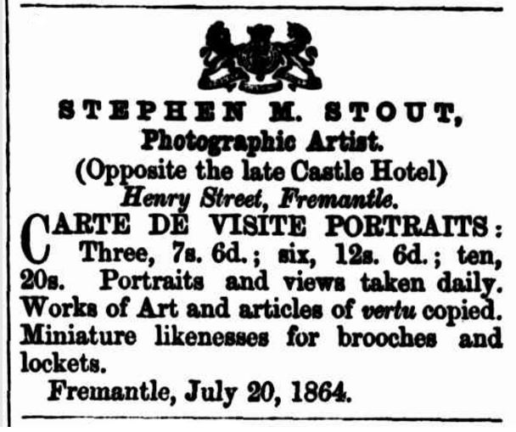
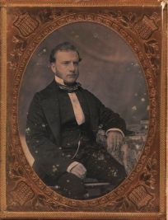
Stout received his conditional pardon in Fremantle in September 1862 and was by that time working as a photographer. He is notable for having taken some of the earliest panoramic photographs of Fremantle and also of Aboriginal people from New Norcia in traditional dress. He had a rented studio in Pakenham Street, Fremantle and was known for producing good likenesses on cards, carte-de-visite for private customers.
Daguerreotype of Stout 1868
Stout appears to have moved between teaching and working as a photographer as competition for photographic work increased. He ran the Wellington Academy in Bunbury between 1868 and 1869 (around the time he married Elinor and she gave birth to their son Ernest.) Back in Perth by October 1870 when their daughter Fanny was born, Stout was again working as a photographer advertising ‘Shilling Portraits’ in Perth. His next opportunity was gaining employment as the schoolmaster at the Pensioner Barracks in Perth in 1873, the only expiree to do so. Unfortunately for Stout, his expenses exceeded his income and owing more than ten times what his assets were deemed to be worth, in 1875 he was declared bankrupt. He continued to work as schoolmaster at the Pensioner Barracks until the beginning of 1878 after which time he moved his family to Geraldton.
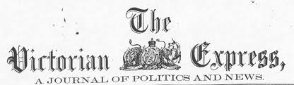
In Geraldton, Stout taught at the local government school and was then appointed editor and manager of the new Victoria Express newspaper in September 1878. He was in partnership with Isaac Walker, a local accountant, merchant and the paper’s bookkeeper. After a falling out with Walker, who accused him of embezzlement but then admitted to making mistakes in his bookkeeping, Stout began his own rival paper, the Observer. The newspaper was published weekly on Tuesdays however it only ran for just over a year between August 1880 and October 1881.

Returning to reside in Perth after his trial, Stout wrote articles for the Daily News and the Morning Herald and gained employment as the Secretary of the Working Man’s Society. Sadly within five short years both Stout and his wife had died and left behind their family of six, orphans ranging in age between 2 and 17 years. The children managed to survive and four of Stout’s daughters made respectable marriages with the sons of free settlers. His daughter Rose married her second husband, Frederick George Chaney in 1904 and her grandson became a state and federal politician, as well as the Lord Mayor of Perth, knighted for his services. Sir Frederick Charles Chaney (1914-2001), Lord Mayor of Perth between 1978 and 1982, previous Australian federal government Member for Perth and Minister for the Navy in the Menzies government (1963-1966).
Stephen Montague Stout died of a weak heart at the age of 55, collapsing outside the Colonial Hospital on Sunday afternoon 11 April 1886. He had certainly made his mark during his 28 years in the colony. Stout’s eventful and colourful life as a schoolmaster, journalist and photographer yielded a long lasting legacy to his adopted home and his descendants live on in Western Australia today.
Editor’s note: During my research I came upon an article on Stout written by WAGS and Convict SIG member Marcia Watson in the June 2003 edition of Convict Links. While having the same subject, our accounts are quite different and explore differing aspects of Stout’s life and his contribution to the Swan River Colony.
First published in the September 2016 Convict Links

