Off to New Zealand Researched by Marcia Watson

On 11 May 1871, the Queen of the South left Fremantle for Lyttleton, near Christchurch, New Zealand. Before sailing, the agent, Mr L.A. Manning, contacted the Colonial Secretary’s office to clarify whether the ship could land ex-convicts in New Zealand. The reply was:
Colonial Secretary’s Office, Perth, Western Australia, 2 May, 1871.
Sir, — In acknowledging the receipt of your letter of the Ist instant, I beg to state that I am not aware of any prohibition existing as to conditional pardon holders landing in New Zealand.
I have, &, Fred. Barlee.

With that information, the Queen of the South left Fremantle, the passengers reported as:
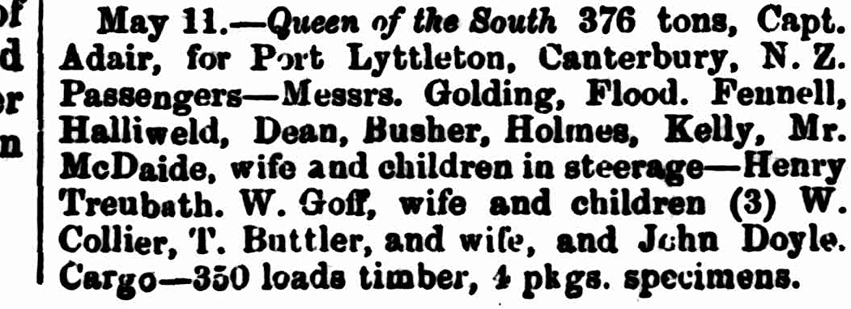
Two weeks later, a newspaper commented on those leaving on the vessel.
“The Queen of the South sailed for Port Lyttleton, Canterbury, N.Z., on the 11th inst., taking as passengers some of the “bone and sinew” of the colony. They go with the idea that they are “bettering themselves.” Let them indulge in that fond delusive hope for the space of a month after reaching “the other side” and - they will wish themselves back again. Some few of the Fenians on their way to the “golden land of the west” were also passengers by the “Queen of the South.” In England these “expatriates” are called “Fenians”; here we are being taught to call them “political prisoners.” In California they will doubtless be dubbed “state prisoners” - What’s in a name? “

They arrived at Lyttleton on 6 June 1871. ,
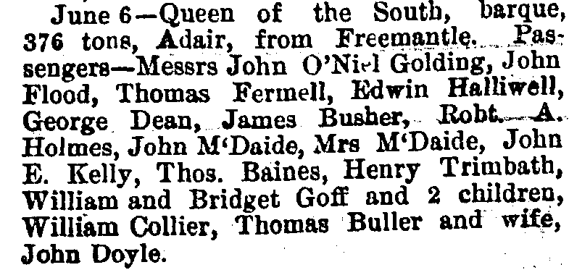
There are several discrepancies and variations in spelling between the two lists, including the number of children William Goff had.

New Zealand authorities would not allow the men with Conditional Pardons to land in the country. The newspapers reported the court case; however, the parliamentary papers perhaps give a more accurate account of the cases and correspondence between New Zealand, Western Australia, and New South Wales governments.

Resident Magistrate’s Court, Lyttleton, 7 June 1871.
John Flood, John Edward Kelly, John Goulding, Thomas Baines, Thomas Fannell, William Goff, Edwin Halliwell, Henry Trenbeth, William Collier, and Charles Barton, passengers by the barque Queen of the South from Western Australia, brought up in the custody of the police on a charge of having committed a breach of an Act entitled “The Introduction of Convicts Act, 1867.”
Depositions were taken from Peter Pender, the Inspector of Police at Christchurch, John McDaide, an ex-warder at Fremantle Prison and James Adair, the master of the Queen of the South.
Peter Pender said under oath that he boarded the barque yesterday and spoke to John Flood, who acknowledged he had come from Swan River Settlement with four others, that they were political prisoners (Fenians), they had received conditional pardons, and that they intended to proceed to Sydney. He had no reason to doubt that Flood’s sentence had not expired. All asserted they were political prisoners and had nothing to do with the other men on board.
John Flood, John Edward Kelly, Thomas Baines, Thomas Halliwell and John Golding were remanded for seven days on bail of £50 each. Subsequently, John Golding produced his pardon, which, on examination, was found to be a free pardon. He was discharged immediately and asked why he had not produced it before. He replied that he had not been asked for it.

Then, William Goff, Edwin Halliwell, Henry Trenbeth, William Collier, and Charles Barton were brought up on the charge of a breach of “The Introduction of Convicts Act, 1867.”
Trenbeth produced his ticket for the expiration of the sentence and was discharged by the Court.
Collier, Barton, Halliwell and Goff all produced their conditional pardons. They were remanded until the next day, when they were convicted and ordered to be kept in custody and re-shipped to the Colony from whence they came, viz., Western Australia. The men were identified as: 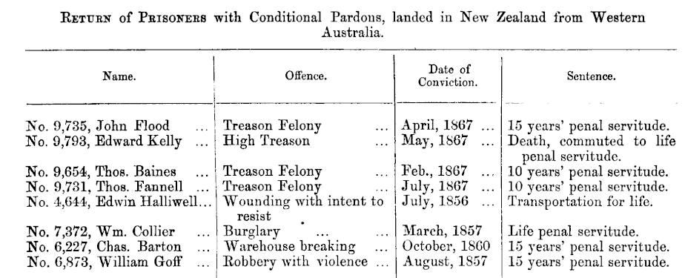
Two men were allowed to stay in New Zealand:
8140 Henry Trenbeth and 9750 John O’Neil Goulding, although Goulding decided to return to Australia with his fellow Fenians.

The Colonial Secretary of New Zealand, William Gisborne, then wrote to the Colonial Secretary of Western Australia on 19 June 1871, pointing out their Act entitled “The Introduction of Convicts Prevention Act, 1867,” and requesting payment for returning the convicts to Western Australia. He explained that these prisoners had been apprehended and taken before the bench in pursuance of the provisions of this Act of this Colony. The four Fenian prisoners were convicted, released on bail, and required to leave this colony. The four other prisoners were convicted and were to be sent back to Western Australia, the Colony to which they were transported. This Government has incurred the expense of one hundred and fifty pounds (£150) to carry this sentence into effect. He requested His Excellency Governor Weld of WA to refund the sum of one hundred and fifty pounds (£150) expended in returning the convicts to Western Australia, as directed by the sentence of the Court, into this Treasury.
Gisborne also requested that the New Zealand Act, “The Introduction of Convicts Prevention Act, 1867,” be publicly notified in Western Australia. In the future, the Act will be enforced to the fullest extent against any person offending against its provisions.

Arrangements were made for the convicts to be returned to Western Australia on a small vessel called the Canterbury when the owner, on second thoughts, became alarmed at the prospect of having four such persons, and the wife of one of them, on board, with a crew of only four sailors and a master. The attention of the Government was drawn to the fact that the Colonial Act had no operation on the high seas. Once the vessel was three miles from the shore, there would be no legal authority for the detention of the convicts on board, and they might demand their release on the nearest land or sue the master of the ship for false imprisonment.

The convicts did not want to return to Western Australia, and communications between Mr C. W. Turner (part owner of the Queen of the South) and the various Governments resulted in the four convicts, Goff, Halliwell, Collier and Barton, being permitted to leave for NSW instead of returning to Western Australia. Gisborne said a search was made in the NSW Statute Book, and no law to the contrary was found against the convicts being returned to NSW. The four Fenians, Flood, Baines, Kelly and Fannell, were also deported to Newcastle, and Golding joined them. A public subscription raised £123 for the Fenians. The proceedings against the captain of the Queen of the South for bringing the men to New Zealand were withdrawn.

The Queen of the South left Lyttleton on 23 June 1871 for Mauritius via Newcastle. She arrived at Newcastle on the 15 July.

The Colonial Secretary of WA, Fred Barlee, replied to Gisborne in August 1871.

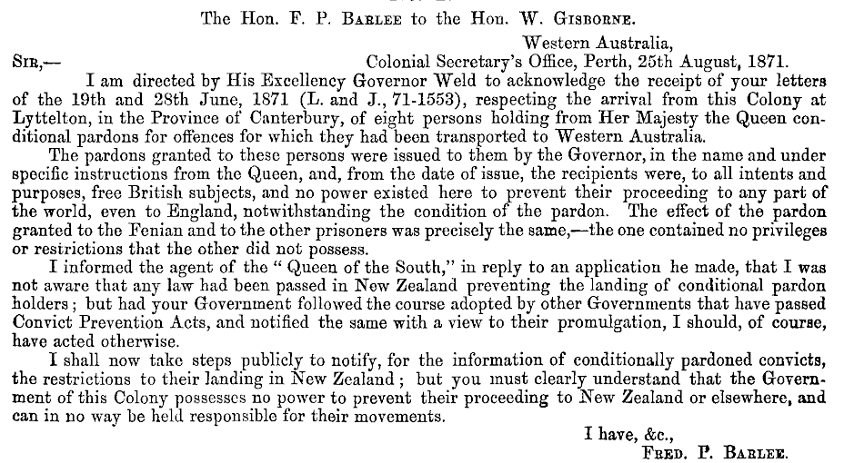

The Perth Gazette and West Australian Times, 12 May 1871, p2
The Perth Gazette and West Australian Times, 26 May 1871, p2
Lyttleton Times, Volume XXXV, Issue 3243, 7 June 1871, Page 2
Note: The spelling of surnames differs from the Western Australian Convicts database. https://waconvicts.fhwa.org.au/
Bridget Goff née McGeogehan and children William John 5 and Adelaide Mary 1.
Parliamentary Papers Appendix to the Journals of the House of Representatives 1871 Session I, Pages 106 to 111. https://paperspast.natlib.govt.nz/parliamentary/AJHR1871-I.2.1.2.1/5?end_date=1871&items_per_page=10&phrase=2&query=john+flood&snippet=true&start_date=1871
West Coast Times, Issue 1796, 3 July 1871, p2.
https://paperspast.natlib.govt.nz/parliamentary/appendix-to-the-journals-of-the-house-of-representatives/1871/I/2531

